Formatting an ASP Gridview & Detailsview using CSS

<!-- sample ASP Gridview using css for formatting -->

<asp:GridView

ID="GridView1"

runat="server"

AllowPaging="True"

C

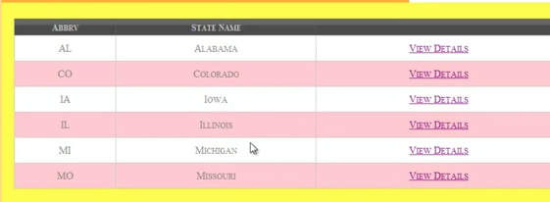

AllowSorting="True"

ASP Gridview Object

AutoGenerateColumns="False"

DataKeyNames="stID"

DataSourceID="AccessDataSource1"

B

A

PageSize="52"

Gridlines="None"

CssClass="cssgridview"

AlternatingRowStyle-CssClass="alt"

PagerStyle-CssClass="pgr"

>

<!-- END -->

/* CSS to format a gridview -- START*/

.cssgridview { width:100%; margin:5px 0 10px 0; border:solid 1px #525252; border-collapse:collapse; text-align:center; font-family: "Comic Sans MS"; color: #7C6F57; background-color: #F7F6F3}

Formats the general Gridview (A)

.cssgridview td { padding:10px; border:solid 1px #c1c1c1; color:#717171; }

Formats the <td> tag inside the table, inside Gridview (B)

.cssgridview td a, a:visited { color:#717171; text-decoration:none; }

Formats the links <a> and visited links (a:visited) inside of the table data <td>

.cssgridview th { padding:10px; color:#fff; background:#424242 url(./images/css/grd_head.png) repeat-x top; border-left:solid 1px #525252; font-size:0.9em; }

Formats the table header <th> inside of Gridview (C)

.cssgridview th a { color:silver; text-decoration:none; }

Formats the links <a> inside of the table header <th> inside of Gridview (C)

.cssgridview th a:hover { color:white; background-color:#7C6F57; text-decoration:underline; }

Formats the behavior when you hover over links (a:hover) inside of the table header <th> inside of Gridview (C)

.cssgridview .alt { background: #fcfcfc url(./images/css/grd_alt.png) repeat-x top;}

Formats the alternating rows inside of Gridview

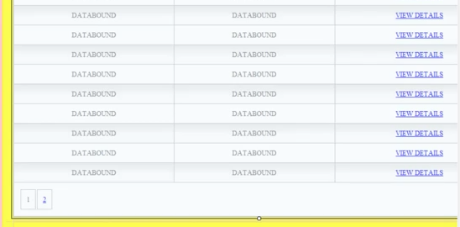

.cssgridview .pgr { background: #424242 url(./css/grd_pgr.png) repeat-x top; }

Formats the pager row across the bottom of Gridview that lets you view the next group of records

.cssgridview .pgr table { margin: 5px 0; }

Pager row is shown as a table, this formats the <table> that displays the page numbers.

.cssgridview .pgr td { border-width: 0; padding: 0 6px; border-left: solid 1px #666; font-weight: bold; color: #fff; line-height: 12px; }

Format the table data <td> in the pager table <table> that displays the page numbers.

.cssgridview .pgr a { color: #666; text-decoration: none; }

Format the links <a> in the pager table (the page numbers you click on).

.cssgridview .pgr a:hover { color: #000; text-decoration: underline; }

Format the behavior when you hover (a:hover) over the page numbers in the pager table.

/* CSS to format a gridview -- END*/

<!-- sample ASP Detailsview using css for formatting -->

C

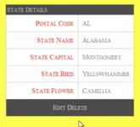

<asp:DetailsView

ID="DetailsView1"

runat="server"

E

AutoGenerateRows="False"

DataKeyNames="stID"

B

A

DataSourceID="AccessDataSource1"

E

D

HeaderText="State Details"

F

CssClass="cssdetailsview"

HeaderStyle-CssClass="header"

G

FieldHeaderStyle-CssClass="fieldheader"

H

ItemStyle-CssClass="item"

AlternatingRowStyle-CssClass="altrow"

CommandRowStyle-CssClass="command"

PagerStyle-CssClass="pager"

>

<!-- END -->

/* CSS to format a detailsview --START */

.cssdetailsview { font-family: "Comic Sans MS"; background-color:#fff; margin:5px 0 10px 0; border:solid 1px #525252; border-collapse:collapse; text-align:center; }

Formats the general Detailsview (A)

.cssdetailsview td { padding:10px; border:solid 1px #c1c1c1; color:#717171; text-align:left;}

Formats the <td> tag inside the table, inside Detailsview (B)

.cssdetailsview .header td { text-align:center; padding:4px 2px; color:silver; background:#424242 url(./css/grd_head.png) repeat-x top; border-left:solid 1px #525252; }

Formats the header text in Detailsview (C)

.cssdetailsview .fieldheader { color:red; width:150px; text-align:right;}

Formats the database field text in Detailsview (D)

.cssdetailsview .altrow { background: #fcfcfc url(./css/grd_alt.png) repeat-x top; }

Formats the alternating rows inside of Detailsview (E)

.cssdetailsview .item {}

Formats the database record text in Detailsview (F)

.cssdetailsview .command { background: #424242 url(./css/grd_pgr.png) repeat-x top; line-height: 20px;}

Formats the command row (Edit, Delete, New, Cancel, Update) inside of Detailsview (G)

.cssdetailsview .command td { text-align:center;}

Formats the <td> tag inside the command row (Edit, Delete, New, Cancel, Update) inside of Detailsview (G)

.cssdetailsview .command a {color:Silver; text-decoration:none; padding:10px; }

Formats the links <a> in the command row (Edit, Delete, New, Cancel, Update) inside of Detailsview (G)

.cssdetailsview .command a:hover {color:Silver; text-decoration:underline; }

Formats the behavior links are hovered (a:hover) in the command row inside of Detailsview (G)

.cssdetailsview .pager {}

The pager row is the list of numbers that are shown when “paging” is enabled to allow you to move from one record to the other. This tag would format the display of those numbers. The .pager CSS could also format the links <a> and link behaviors such as a:hover & a:visited. Syntax would be similar to the .command CSS. The pager row is not displayed in the example above, but would normally be located under the command row near (H)

/* CSS to format a detailsview --END */